**Object Oriented Software Engineering**

**Submitted To:** Sir Mukhtiar Zamin

**Submitted By:**

Rameen Naeem

(SP20-BSE-057)

Date: 10-10-21

**Use Case Diagram:**

**Fully dressed Use case of Register**

|  |  |
| --- | --- |
| **Use case:** | Register |
| **Primary Actor:** | User |
| **Scope:** | Personal Safety App |
| **Level :** |  |
| **Stakeholders:** | User: user wants a fast and secure system which can help him in the case of any emergency. |
| **Preconditions:** | User must have opened the app. |
| **Success Guarantee:** | User was registered in the system. |
| **Special Requirements:** | Verification of the number. |
| **Main Success Scenario:** | |
| **Actor Action:** | **System Response:** |
| The user opens the application: | The system asks the user to register himself in the system by entering his/her phone number, username, email & password. |
| The user enters his/her details for registration. | The system sends an OTP on the user’s phone number for verification. |
| The user enters the OTP code for verification. | The systems registers the user. |
| **Alternative Flow:**  If user enters incorrect OTP an error will be generated by the system. The system will ask the user to check and enter the code again. | |

**Fully dressed Use case of Enable Tracking**

|  |  |
| --- | --- |
| **Use case:** | Enable Tracking |
| **Primary Actor:** | User |
| **Scope:** | Personal Safety App |
| **Level :** | User-goal |
| **Stakeholders:** | User: user wants a fast and secure system which can help him in the case of any emergency. |
| **Preconditions:** | User must be logged in the app. |
| **Success Guarantee:** | User can send emergency message with location URL. |
| **Main Success Scenario:** | |
| **Actor Action:** | **System Response:** |
| The registered user opens the application: | The system asks the user to enable the location. |
| The user enables the location: | The system will track the user location. |
| **Alternative Flow:**  If user do not allows the app to access his/her location, the app would not go further. | |

**Fully dressed Use case of Add Police Station:**

|  |  |
| --- | --- |
| **Use case:** | Add Police Station |
| **Primary Actor:** | Admin |
| **Scope:** | Personal Safety App |
| **Level :** | User-goal |
| **Stakeholders:** | User: user wants a fast and secure system which can help him in the case of any emergency. |
| **Preconditions:** | User must be registered the app. |
| **Success Guarantee:** | User can send emergency message to the added contacts. |
| **Special Requirements:** | User must save the contacts after adding them. |
| **Main Success Scenario:** | |
| **Actor Action:** | **System Response:** |
| The user clicks on add contact button: | The system asks the user to add contact details. |
| The user enters contact details and press save button: | The system saves the added contacts. |
| **Alternative Flow:**  If user do not saves the contacts, all the details user entered will discarded. | |

**Fully dressed Use case of Read Instructions**

|  |  |
| --- | --- |
| **Use case:** | Read Instructions |
| **Primary Actor:** | User |
| **Scope:** | Personal Safety App |
| **Level:** | User-goal |
| **Stakeholders:** | User: user wants a fast and secure system which can help him in the case of any emergency. |
| **Preconditions:** | User must be logged in the app. |
| **Main Success Scenario:** | |
| **Actor Action:** | **System Response:** |
| The user clicks on the read instructions button: | The system will display the page with instructions written on it. |
| The user clicks on exit button: | The system will take the user to the main menu. |
| **Alternative Flow:**  None. | |

**Fully dressed Use case of Modify Police Stations:**

|  |  |
| --- | --- |
| **Use case:** | Modify Police Stations |
| **Primary Actor:** | Admin |
| **Scope:** | Personal Safety App |
| **Level :** | User-goal |
| **Stakeholders:** | User: user wants a fast and secure system which can help him in the case of any emergency. |
| **Preconditions:** |  |
| **Main Success Scenario:** | |
| **Actor Action:** | **System Response:** |
| The admin clicks on the remove police station button. | The system will display the page with option for removing different police stations |
| The user clicks on view button: | The system will show user the added police stations. |
| **Alternative Flow:**  None. | |

**Brief Level Use Cases:**

**Register:**

This use case starts after opening the application, as a user opening it for the first time so he/she is not registered in the system. The System prompts the user for a Name, number, User Name and password. The user enters his/her phone number and an OTP code sent to the user through system. The system validates the entered phone number and OTP code, making sure that the entered number is a valid number in the System. The user is registered in and returned to the home page as a registered User. The use case ends.

**Enable Tracking:**

This use case starts whenever user clicks on Send Alert Button. This use case asks user to enable his/her location so when the user sends the emergency message to anyone, they can also have his/her location URL by which they can track the user easily. The use case ends.

**Read Instructions:**

This use case starts when user login into Application where user finds different options. If user wants to know about the application, working of application etc. he will simply open the instructions where the user finds different key points explaining the use of app. The use case ends.

**Add Police Station:**

This use case starts when Admin press the add Police Station button to add police Stations in the app for help users in an emergency situation. The Admin will simply click on the add Police Station button and will enter the details of police station and save it in the system. The use case ends.

**Modify Police Station:**

This use case starts when the admin wants to see the police station he/she has added and saved in the system for any emergency situation for the users. In this use case user can view the added police station and can delete any police station from the system if the admin wants to. The use case ends.

**Domain Model:**

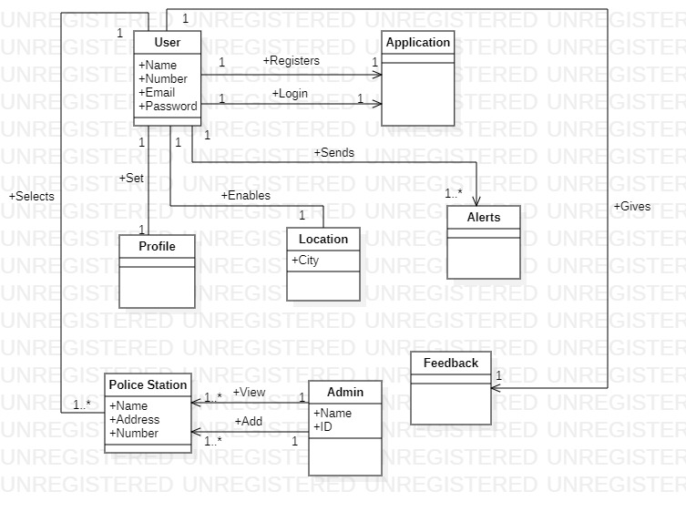

**System Sequence Diagram**

1. **Register**

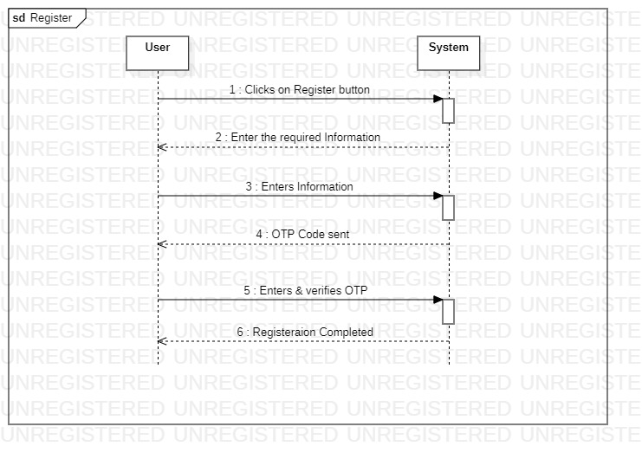

1. **Enable Tracking**

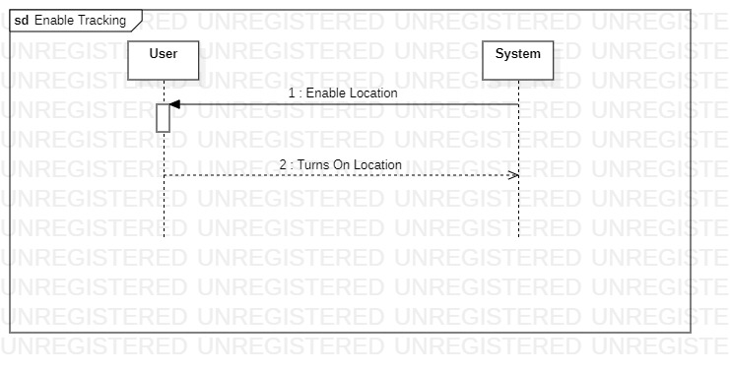

1. **Add Police Station**

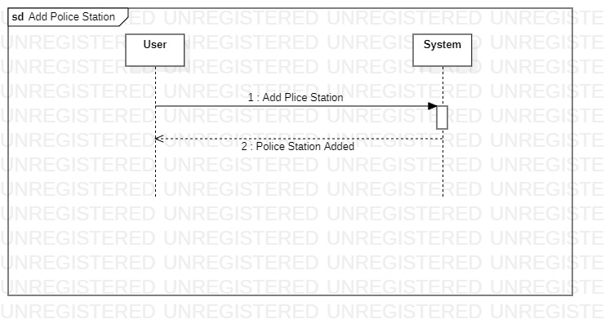

1. **Modify Police Station**

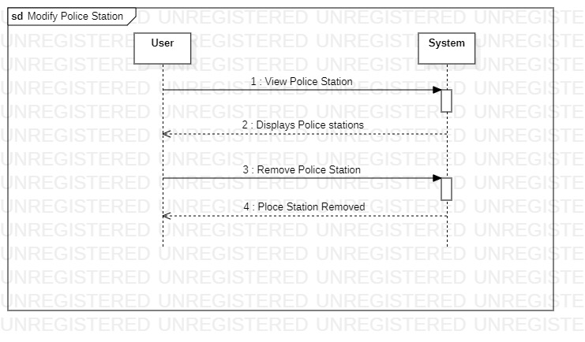

1. **Read Instructions**

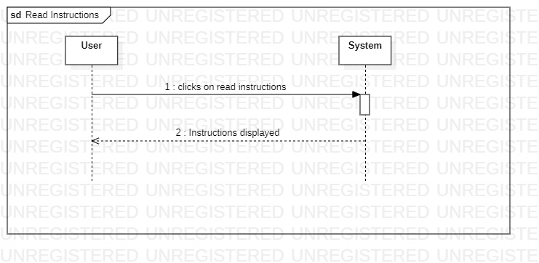

**Operation Contract**

|  |  |
| --- | --- |
| Operation | Register |
| Cross Reference | Use Case – Register |
| Pre-Condition | Application is already installed. |
| Post-Condition | User was registered. |

|  |  |
| --- | --- |
| Operation | Enable Tracking |
| Cross Reference | Use Case – Enable Tracking |
| Pre-Condition | User is already authenticated |
| Post-Condition | Tracking was enabled. |

|  |  |
| --- | --- |
| Operation | Read Instruction |
| Cross Reference | Use Case – Read Instruction |
| Pre-Condition | User is already authenticated |
| Post-Condition | “Instructions” was displayed. |

|  |  |
| --- | --- |
| Operation | Add Police Station |
| Cross Reference | Use Case – Add Police Station |
| Pre-Condition |  |
| Post-Condition | Police Station was added in the system. |

**_____________________________________________________-_**

|  |  |
| --- | --- |
| Operation | Modify Police Station |
| Cross Reference | Use Case – Modify Police Station |
| Pre-Condition |  |
| Post-Condition | Police station list was modified. |